Subject: ISTQL Summer School August 2022-Machine Learning for Social Scientist
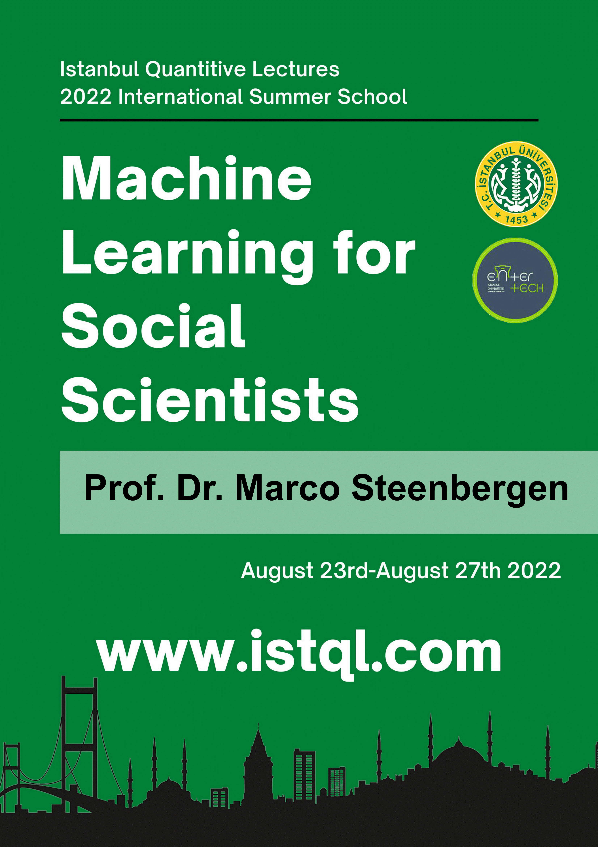
Dear Colleagues,

As Istanbul Quantitative Lectures team, we are proud to announce the 10th ISTQL 2022!

Prof. Dr. Marco Steenbergen from University of Zurich/Switzerland will be teaching the course "Machine Learning for Social Scientist" between the 23th and 27th of August 2022. This year we are offering course through one week period (5 days with 4 hours a day; total of 20 hours). The course venue will be announced soon on our website.

The course aims to give participants the ability to use machine learning techniques and combine their knowledge to model the data in open source R program. These techniques are the high level, less common, highly sophisticated techniques which might create a selective advantage while publishing in top SCI and SSCI Journals.

Applied Statistics Using R is also a course to be given to beginners in R. This course will take place 20th August and will last 6 hours. It will be given by İstanbul University lecturers.

The language of the courses is English. The methods will be approached both in theoretical and practical bases with the aim of providing the participants the ability to use the techniques for their personal research projects. The organization is open to both students with required background, academicians who would like to widen their horizons and also the data science practitioners from different industries.

Early registration ends on 10th of June, please check our website for fees and course registration. For course registration and detailed information please check our website: www.istql.com. It is very much appreciated if you could also pass this information to your colleagues, researchers or students, who you believe that they may be interested in. We are hoping to see you in ISTQL-İstanbul this summer.

Sincerely,

Professor Cigdem Aricigil Cilan (PhD)
Director of Istanbul Quantitative Lectures
Istanbul University/ School of Business Administration
Quantitative Methods Department/Founder of Latent Research
ccilan@istanbul.edu.tr
(Please note that your e-mail addresses have been reached through your University websites.)
Ekler:
1. afis.png

